|  |  |
| --- | --- |
|  | |
| **ALL 116: COA – Forecast [Edit Shortfall %]**  **Functional Specification** | |
| Department: CMA CGM Commercial Allocation  Project: *DATAWAYS*  JIRA ID: ALL-116  Author(s): *Infosys* | |
| **Doc Reference:**  **Date:**  **Version:**  **Status:** | ALL-116 COA – Forecast Edit Shortfall %  31.07.24  1.0  Draft To Be Reviewed |
| Classification: **Internal** | |

REVISIONS

|  |  |  |  |
| --- | --- | --- | --- |
| **Version** | **Date** | **Author** | **Subject** |
| 1.0 | 07-Aug-24 | Tushar Sharma | Document creation |
|  |  |  |  |

**REVIEWS**

|  |  |  |  |  |  |
| --- | --- | --- | --- | --- | --- |
| **Name** | **Title** | **Version** | **Date** | **Company** | **Signature** |
| Prabhu SESHADRI | IT Domain Lead | 1.0 |  | CMA CGM | Prabhu SESHADRI |
| HIENG Laurent | Product Owner | 1.0 |  | CMA CGM | HIENG Laurent |

APPROVALS

|  |  |  |  |  |  |
| --- | --- | --- | --- | --- | --- |
| **Name** | **Title** | **Version** | **Date** | **Company** | **Signature** |
| HOELLARD Damien | Lead Product Owner | 1.0 |  | CMA CGM | HOELLARD Damien |
| HIENG Laurent | Product Owner | 1.0 |  | CMA CGM | HIENG Laurent |

DISTRIBUTION LIST

|  |  |  |  |  |
| --- | --- | --- | --- | --- |
| **Name** | **Title** | **Company** | **To** | **Cc** |
| HOELLARD Damien | Lead Product Owner | CMA CGM | X |  |
| Prabhu SESHADRI | IT Domain Lead | CMA CGM | X |  |
| HIENG Laurent | Product Owner | CMA CGM | x |  |
| Veronique JOUSSELLIN | IT Domain Owner | CMA CGM |  | X |
| Julien D’ELIA | Enterprise Architect | CMA CGM |  | X |
| Youssef ATIK | Solution Architect | CMA CGM |  | X |
| Rudy MACARONUS | Chief Architect | CMA CGM |  | X |
| Victor BONY | Project Manager | CMA CGM |  | X |
| Ganesh IYER | Proxy Product Owner | Infosys |  | X |
| Ellina GALCHENKO | Product SME | Infosys |  | X |
| Akshita AHUJA | Product SME | Infosys |  | X |
| Dinesh Maurya | Product SME | Infosys |  | X |
| Savli TAPRE | Product SME | Infosys |  | X |
| Aishwarya RAJAN | UX Team | Infosys |  | X |
| Steffi SOLANKI | UX Team | Infosys |  | X |
| Abhishek KUMAR | Product SME | Infosys |  | X |
| Ben PAUL | Product SME | Infosys |  | X |
| Tushar Sharma | Product SME | Infosys |  | X |
| Tameshwar SAHU | Solution Architect | Infosys |  | X |
| Tapas SARKAR | Solution Architect | Infosys |  | X |
| Bala Chami | Scrum Master | Infosys |  | X |
| Sinchu PANICKER | PMO | Infosys |  | X |

CONTENTS

1 - Requirements 4

**1.1** Document References 5

**1.2** New or Modified Objects 5

**1.3** Acronyms & Glossary 5

2 Detailed Design 6

**2.1** Business Context and Scope 6

The Edit Shortfall % function on the Allocation screen of the Forecast Per Voyage screen in the Cargo Flow Portal allows users to modify the shortfall percentage at the Cargo Type level within the Forecast column. This feature becomes accessible once the required mandatory filters have been applied by the user to view the allocation section on the Forecast Per Voyage Screen 6

**2.2** .Business Constraints or Assumptions 6

**2.3** Functional Solution Risk 6

**2.4** Requirement Details 6

**2.5** Process Flow and Domain Entities 7

**2.6** UI / UX Design 7

**2.7** Validation and Rules 11

**2.8** Setups and configurations 12

**2.9** Processing definition 12

**2.10** Functional Test Cases 15

3 - Technical Details (Optional) 16

# - Requirements

|  |  |
| --- | --- |
| **Requirement ID** | **User Story / Requirement Description** |
| ALL-116 | ALL-116 COA – Forecast Edit Shortfall % |

## 

## 

### Document References

|  |  |  |  |  |
| --- | --- | --- | --- | --- |
| **Reference** | **Description** | **Version** | **Date** | **Author** |
| ALL-140 | My Scope of Services | JIRA | NA | Savli Tapre |
| ALL-46 | COA - Manually Publish COA Template to Voyage (Screen) | JIRA | NA | Kumar Abhishek |
| ALL 1133 | Consume COA by Bookings [Rules for Commercial Bookings] | JIRA | NA | Kumar Abhishek |
| ALL-127 | COA – Calculating available COA [Back End] | JIRA | NA | Dinesh Maurya |
| ALL-139 | Roles and Authorization | JIRA | NA | Ellina Galchenko |

### New or Modified Objects

|  |  |
| --- | --- |
| **Components involved and purpose (Part of technical Document)** | |
| N/A | N/A |

### Acronyms & Glossary

|  |  |  |
| --- | --- | --- |
| **Term** | **Acronym** | **Definition** |
| Booking Consumption | Booking Consumption | It is the consumption of TEUs, Tons and no. of units that is captured under each booking. |
| Laden Container Bookings | Laden Container | Laden container bookings refer to reservations made for shipping containers that are already filled with cargo. These containers are ready to be loaded onto a vessel for transport by sea. |
| Paying Empty bookings | Paying Empty | These are in a way commercial bookings wherein movement done for an empty container also generates revenue for the carrier. In those bookings, container is owned by shipper and not by carrier. |
| Dangerous Goods | DG | A dangerous good (also known as hazardous material or hazmat) is any substance or material capable of posing an unreasonable risk to health, safety, and property when transported in commerce |
| Out of Gauge | OOG | Cargo that cannot be loaded on a dry container due to its dimensions (height, width, and length) or weight is called Out Of Gauge (OOG) cargo. This type of cargo is transported on a open top container or flat rack container |
| Break Bulk | BB | Break bulk is the system of transporting goods in pieces separately, rather than being shipped in a container. Goods shipped in crates, bags, boxes, drums, barrels without the use of container are referred to as break bulk cargoes |
| Refrigerated Containers | Reefer | Refrigerated containers, also called reefer containers, are used for goods that need to be temperature controlled during shipping. Reefer containers are equipped with a refrigeration unit connected to the power supply on board the ship. |

# Detailed Design

### Business Context and Scope

### The Edit Shortfall % function on the Allocation screen of the Forecast Per Voyage screen in the Cargo Flow Portal allows users to modify the shortfall percentage at the Cargo Type level within the Forecast column. This feature becomes accessible once the required mandatory filters have been applied by the user to view the allocation section on the Forecast Per Voyage Screen

### .Business Constraints or Assumptions

 Assumption is that allocation check is up-to date and synchronized as per business needs to access and display right information on the list of existing COA templates.

***Disclaimer: User must be having required authorization and access to the Cargo Flow Portal. (covered in user story ALL-139 COA-Roles and Authorization)***

### Functional Solution Risk

Na

### Requirement Details

The cargo flow user should be able to access the Cargo Flow Portal and should be able to access to Forecast Per Voyage Screen. The user shall be able to select the Booking Country ,Booking Branch Office ,Time Range and should be able to apply all these filters .On the selection of the filters the user would be able to visualize the allocations on the forecast screen as per his selection.

The user will be able to view the Edit Shortfall % input box with Apply button on the allocation section of the Forecast Per Voyage Screen

### Process Flow and Domain Entities

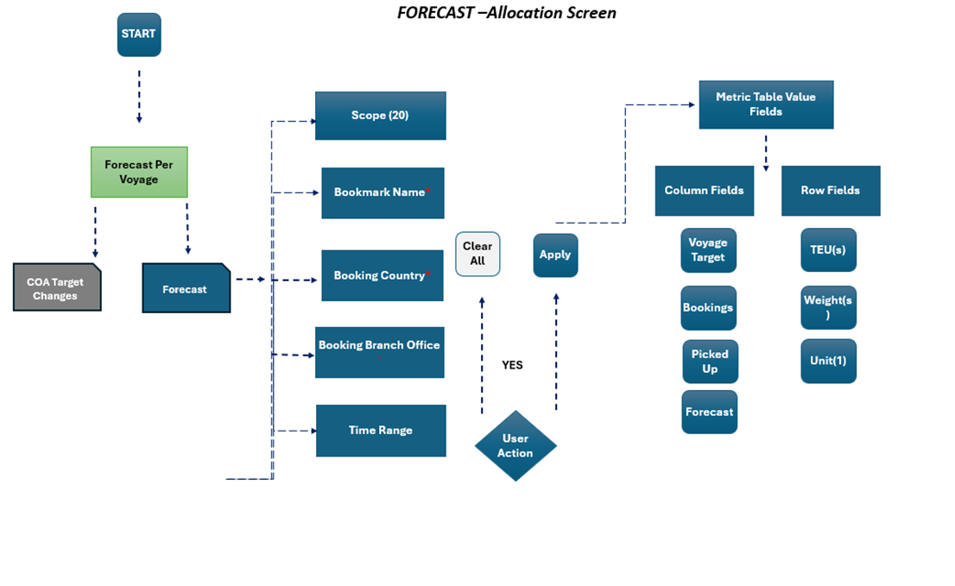

### UI / UX Design

**Mockup on Figma:** https://www.figma.com/design/xy8DT97bl6eT0aOZUqAnsY/DATAWAYS-COA?node-id=3165-751409&node-type=canvas&t=3YlIhyL7zDLbx5xM-0

1. Default View of the Forecast Per Voyage screen will have:
   * + 1. A header “**Forecast Per Voyage**” on the top left corner below the breadcrumbs.

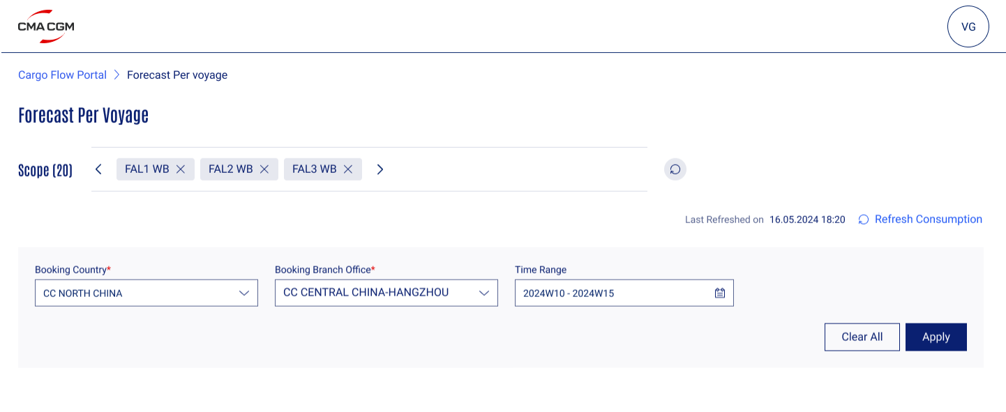

1. Based on the service bounds filters applied as per the setting the user has maintained in **My Scope of Services**, will be visible.

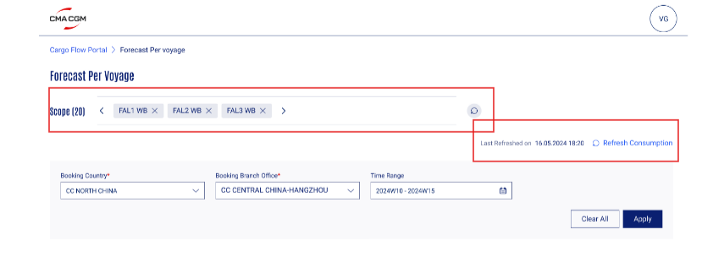

1. Mandatory fields to be updated by the user marked with Asterix in color red * are ‘Booking Country' and “Booking Branch Office”. Field ‘Time Range’ is not mandatory.

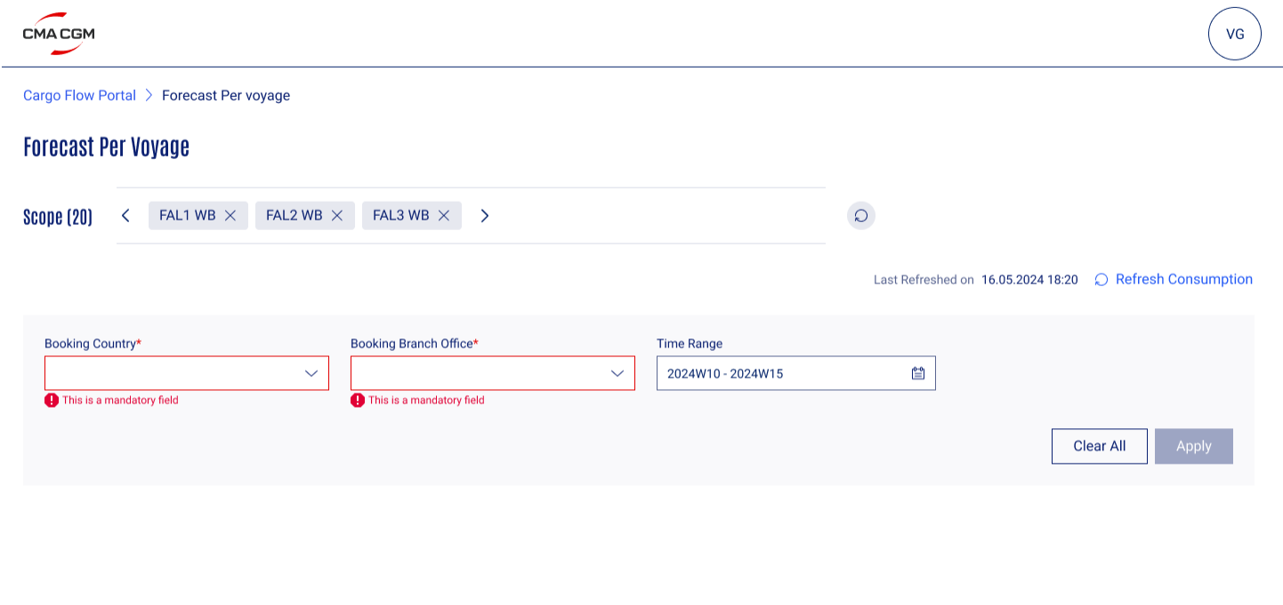

1. The Mandatory fields Booking Country, Booking Branch Office and Time Range has a dropdown feature. The user will also have the ‘Clear All’ and ‘Apply’ button on the bottom left of the Forecast screen.

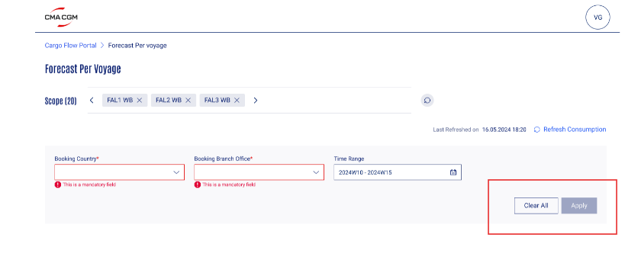

1. Once the user clicks on the ‘Apply’ button value field table for the Forecast screen will be displayed.
   1. The user will have 2 tabs ‘Long Leg’ and ‘Short Leg’
   2. By default, Long Leg tab will be on display.
   3. The user can see the matrix table for service week of CVN in specified ‘dimensions’ and ‘units’ within rows and columns.
   4. The columns will display ‘Voyage Target (Standard Alloc), Bookings, Picked-Up and Forecast’.
   5. The rows will display Unit of Measurements in Rows as, TEUs, Weights and Units.
   6. The table further expands for the user to check the how the allocation is spread across from top down.
   7. The Default Shortfall % input box with the Apply button is placed both for Long Leg and Short Leg and would become editable when the user clicks the Edit Button

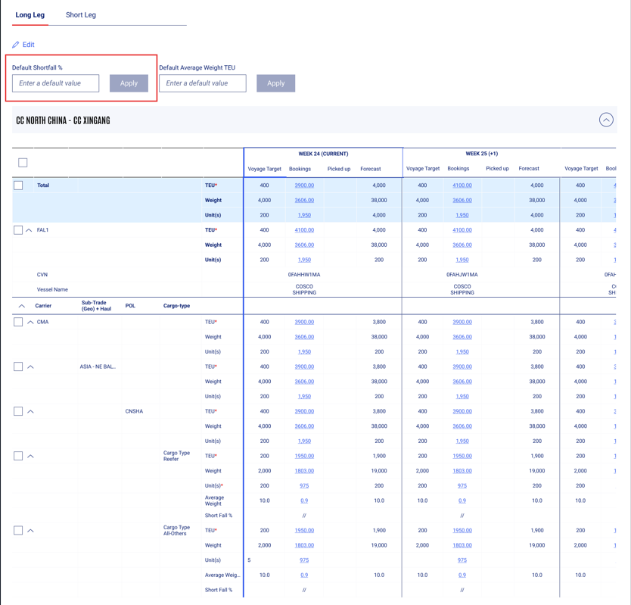

### Validation and Rules

Below are the detailed definitions for attributes, buttons, and error messages in search & display and editing boundary templates.

|  |  |  |  |  |  |  |  |
| --- | --- | --- | --- | --- | --- | --- | --- |
| **SR** | **Label or Fields** | **Description** | **F** | **A** | **D** | **List** | **Rules** |
| 1 | POL | Port of Loading to be selected by the user | FA | M | E |  |  |
| 2 | Cargo Type | Cargo Type to be selected by the user | LOV | M | E |  |  |
| 3 | Clear All | This button to be clicked by the user to discard any changes made within the table | BT |  | E |  |  |
| 4 | Apply | This button to be clicked by the user to apply to view the booking consumption the table. | BT |  | E |  |  |
| 5 | Alloc TEU | Maximum TEU to be added by the user | FN | O | E |  |  |
| 6 | Alloc TONS | Maximum weight (in tons) to be added by the user | FN | O | E D |  |  |
| 7 | Alloc Unit(s) | Maximum allowed units to be added by the user | FN | O | E |  |  |
| 8 | Booking Country | Saved Booking Countries to appear in the list | CB | M | E |  |  |
| 9 | Booking Branch Office | Booking Branch Office pertaining to countries to appear in the list | CB | M | E |  |  |
| 10 | Time Range | Calendar to be displayed week-wise from current to 5 weeks | CB | O | E |  |  |

**Legend**

|  |  |  |  |  |  |  |  |  |
| --- | --- | --- | --- | --- | --- | --- | --- | --- |
| Format | CB | Check Box | Attribute | M | Mandatory | Display | D | Field disabled |
| FA | Field alpha | O | Optional | E | Field Enabled |
| FN | Field numeric |  |  | R | Read Only |
| LOV | List of Value |  |  | H | Hidden |
| DA | Date |  |  |  |  |
| BT | Button |  |  |  |  |
| DT | Date Time |  |  |  |  |

### Setups and configurations

N/A

### Processing definition

Following business rules must be implemented:

|  |  |  |
| --- | --- | --- |
| **ALL- 116** | | |
| **ALL-116: COA – Forecast Edit Shortfall %** | | |
| **BR01** | **Functionality and Navigation Steps to Allocation Section on Forecast Screen**  The user will be able to select the filters on the Forecast Screen header as explained in the **Ref Doc** *ALL-114 , ALL-1944 , ALL-1945 , ALL-606*  .The user after selecting three mandatory fields will be able to visualize the allocations assigned as per the Booking country ,Booking Branch Office and Time Range  **Mandatory Fields:** The user will have 2 mandatory fields to fill in the required details to proceed.   1. **Booking County*:** The user can see the Booking Country filter field with the Sales Office(s) for which I have the roles and authorizations. 2. **Booking Branch Office:** The user can select Booking Branch Office from the dropdown list. Once the selection is made the user can save that selection to persist for future navigations to the screen.   **Non-Mandatory Fields:** The user can select the date range from the **“Time Range”.** And by default, the time range is always set to current week and 5 consecutive weeks  The functionality of the buttons and navigation follow the business rules outlined in   * **ALL-114: COA – Forecast Screen [Header]** * **ALL-1945: COA – Forecast Screen [Refresh Dashboard]** * **ALL-606: COA – Forecast Screen [Allocation Section]**     **Clear All:** Users can reset all filter values to their default state by clicking the "Clear All" action button.  **Apply:** Clicking the "Apply" button will proceed to the Forecast Per Voyage allocation screen, provided all mandatory fields Booking Country and Branch Office are selected. If any mandatory fields are missing, the system will not enable the apply filter and prevent navigation to the allocation screen. | |
| *Note* | *The functionality of the buttons and navigation follow the business rules are defined in Doc Ref ALL-606* | |
| **BR02** | **Applying the “Edit Shortfall % “ at the Header Level**  The Allocation screen displays a leg-wise 'Default Shortfall %' input box, accessible by clicking the 'Edit' button. Once edited functionality is clicked and the “Apply” button is applied as a default shortfall percentage at the header level for all allocations within the Forecast column, specific to the selected Booking Country and Booking Branch Office. This action updates the Cargo Type Shortfall % exclusively for the Forecast column, leaving other Shortfall % fields blank."  **Shortfall % applied at the Header level will be distributed as follows:**   * **Bulk Application to All Voyages:** Checking the checkbox below Booking Country and Booking Branch Office will apply the Header level Shortfall % to all Voyages within the selected Cargo Type. (Check Box marked in Blue) * **Selective Application to Voyages:** To apply the Header level Shortfall % to specific Voyages, select any level from Carrier to POL for the desired Voyages. This will impact the Shortfall % at the cargo type level for the selected voyages equivalent to Shortfall% in the header |
| *Note* | *Users can enter a shortfall percentage value between 0 and 100* |
| **BR03** | **Individual Shortfall Allocation**  Users can maintain individual Forecast Shortfall % values at the Cargo Type level within the Forecast column. Shortfall percentages for Voyage Target, Bookings, and Picked Up columns will remain blank. The Forecast Shortfall field can be either pre-populated with the default shortfall percentage applied at the header level or left empty if no default is set. Users have the flexibility to edit the shortfall percentage at the individual Cargo Type level within the Forecast column to manage shortfall values independently. | |
| *Note* | The forecast keyed by the user shall be stored at voyage level in the COA per Voyage back-end table. Please refer to the ALL 1795 – COA Audit Trail. | |
| **BR04** | **Change Of Shortfall Value at Header Level**  Users can modify Shortfall values at the Header level to adjust the overall forecast for the selected Voyage and CVN within the Cargo Type Child Level. Changes made at the Header level will not overwrite individual Shortfall values entered at lower individual levels if the user has defined shortfall at individual level | |

### Functional Test Cases

|  |  |  |  |  |
| --- | --- | --- | --- | --- |
| **Test Case #** | **Rule** | **Functional Test** | | **Expected Results** |
| **ALL-116: COA – Forecast Edit Shortfall** | | | | |
| **TC01** |  | | Check whether all the elements on the Operational Restrictions screen matches with the UX/UI Mock-ups | Refer section 2.6 UX/UI Designs. |
| **TC02** | BR01 | | The user on the Forecast at Voyage screen can access Forecast tab | The Forecast Tab is enabled for the user. |
| **TC03** | BR01 | | Scope of Services | The user should have the service bounds filters applied as per the setting they have maintained in My Scope of Services. |
| **TC04** | BR01 | | Mandatory Fields- Booking Country Selection and Booking Branch office | The user should not be able to move ahead to the flow unless the mandatory fields are selected |
| **TC05** | BR01 | | Non- Mandatory Fields | Time Range field should be enabled for the user to select the date range. |
| **TC06** | BR01 | | Time Range | By default, the time range is always set to current week and 5 consecutive weeks |
| **TC07** | BR01 | | Action Buttons | Clear All and Apply button should be enabled. |
| **TC08** | BR02 | | Edit button to change the shortfall % | Pressing editing button should enable the input box for the Shortfall % |
| **TC09** | BR02 | | Apply Shortfall % at Header level | Shortfall to be applied to Forecast at Cargo Type Level for all the Voyage and CVN |
| **TC10** | BR03 | | Editing the Shortfall Cargo Type at Individual Level | The shortfall % should be updated at Individual level and not at header level |
| **TC11** | BR02 | | Shortfall % values to Range from 0 to 100 | Other values out of the range should give not be accepted and not applied |

# - Technical Details (Optional)

Technical solution will be done by architect and development teams.

- End of document –